**AWS Task-3**

**Launch two ec2-instances and connect it to a application load balancer, where the output traffic from the server must be an load balancer IP address**

**Step 1 : creating the EC2 instance named as EC1 and EC2**

**Step 2: create the Target group , select the instance , include as pending and create the policy**

**Step 3 : create the load balance in Application LB , select the Available zone for LB I have select 2 Available Zone us-east-1a (use1-az6) , us-east-1b (use1-az1) , select the Security group instant was launched and select the listeners and routing , Default actionInfo**

**Forward to**

**AWSTask-3  
If we need we can use the tag it’s a optional**

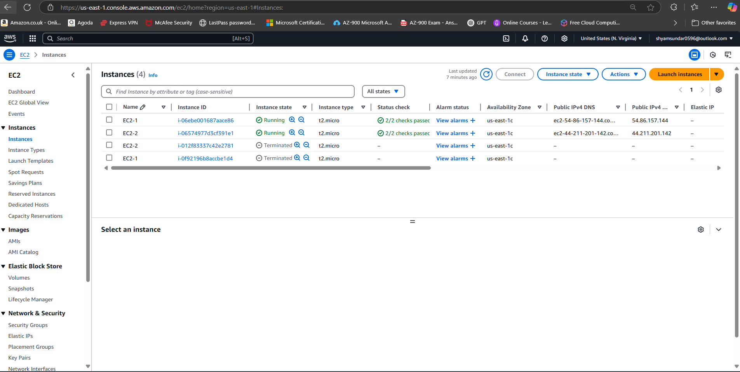

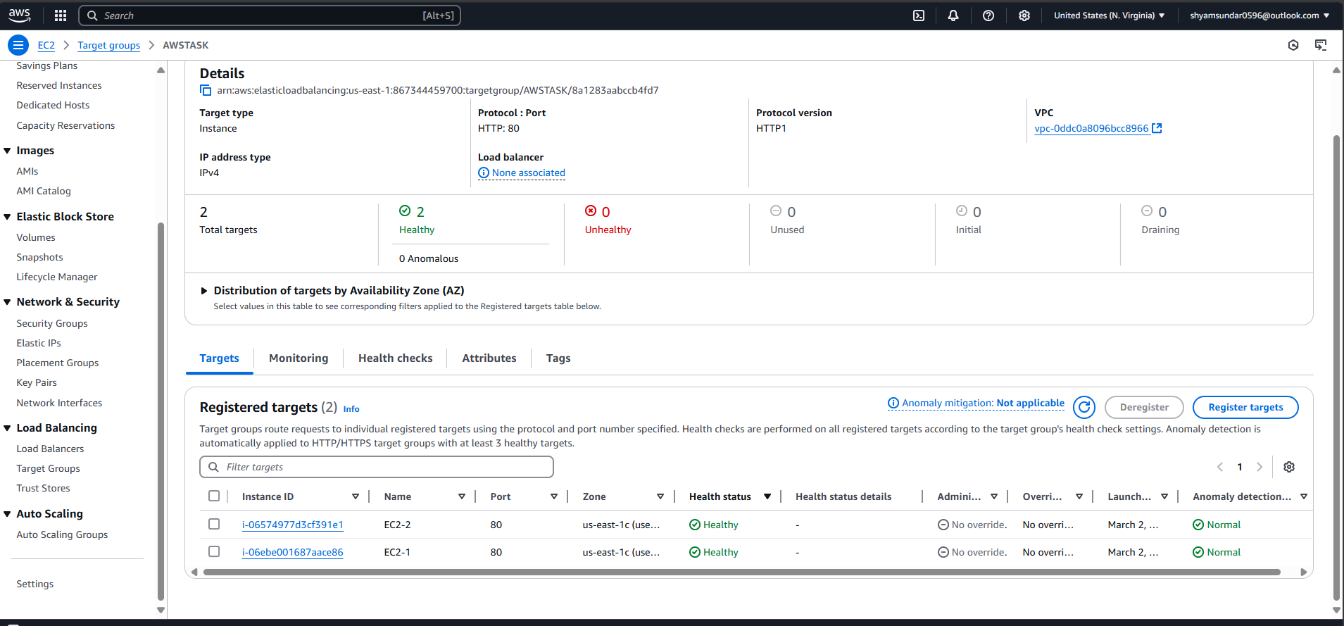

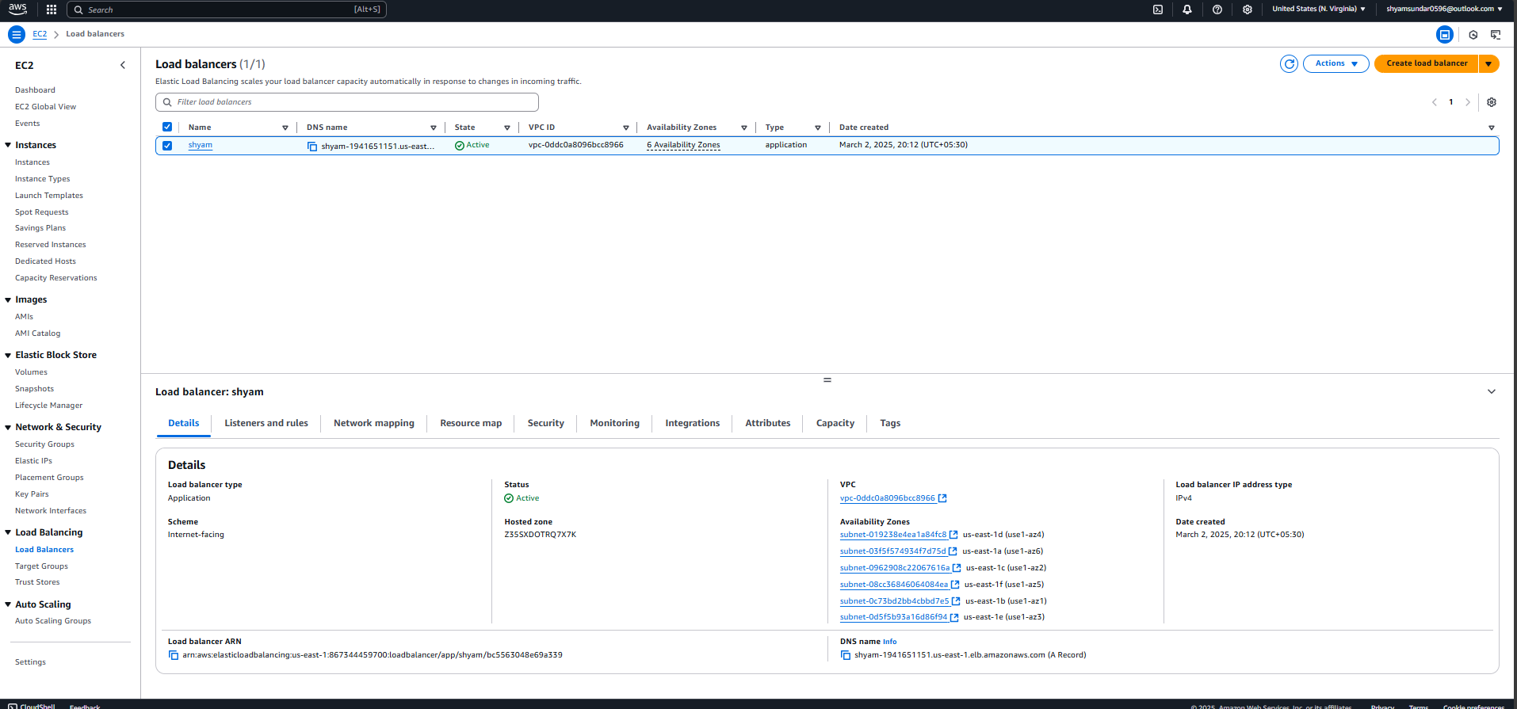

**Create a S3 bucket, with no public access and upload files to the bucket & view the logs using cloudwatch for the uploaded files.**

Step 1 : created the S3 bucket

Step 2 : add the imsge in HTML

Step 3: for the bucket level we off the publick level access

Step 4: create the 2 IAM user and provide the Permission for admin control

Step 5: create the bucket policy like for one IAM user need to access and another IAM user need to block the access for the bucket

{

"Version": "2012-10-17",

"Statement": [

{

"Effect": "Deny",

"Principal": {

"AWS": "arn:aws:iam::867344459700:user/samsundar"

},

"Action": "s3:GetObject",

"Resource": "arn:aws:s3:::mylovetest-1/index.html"

},

{

"Effect": "Allow",

"Principal": {

"AWS": "arn:aws:iam::867344459700:user/Learningaccount"

},

"Action": "s3:*",

"Resource": "arn:aws:s3:::mylovetest-1/index.html"

}

]

